CSE3506 Essentials of Data Analytics

Name : Revanth Bhargava Boyidi
Reg. No. : 19BCE1177
Lab Exercise: 9-Gradient Descent

Objective: Optimize (minimize) the given function using gradient descent algorithm
f(x) = 1.2 (x-2)² + 3.2

Methods:
- Create a sequence of elements in a vector
- Define the function to optimize
- Plot the function
- Calculate the gradient
- Implement gradient descent
- Conclusions

# Clearing the screens
rm(list=ls())
# create a sequence of elements in a Vector
#to generate sequences when plotting the axes of figures or simulating data.
xs <- seq(0,4,len=20)
xs
## [1] 0.0000000 0.2105263 0.4210526 0.6315789 0.8421053 1.0526316 1.2631579
## [8] 1.4736842 1.6842105 1.8947368 2.1052632 2.3157895 2.5263158 2.7368421
## [15] 2.9473684 3.1578947 3.3684211 3.5789474 3.7894737 4.0000000

# define the function we want to optimize
f <- function(x) {1.2 * (x-2)^2 + 3.2}

# plot the function
plot(xs , f (xs), type="l",xlab="x",ylab=expression(1.2(x-2)^2 +3.2))
# calculate the gradient df/dx
grad <- function(x){
1.2*2*(x-2)
}
# df/dx = 2.4(x-2), if x = 2 then 2.4(2-2) = 0
# The actual solution we will approximate with gradient descent
# is x = 2 as depicted in the plot below

#lines (c (2,2), c (3,8), col="red",lty=2)
#text (2.1,7, "Closedform solution",col="red",pos=4)

# gradient descent implementation
x <- 0.1 # initialize the first guess for x-value
xtrace <- x # store x -values for graphing purposes (initial)
ftrace <- f(x) # store y-values (function evaluated at x) for graphing purposes (initial)
stepFactor <- 0.01 # learning rate 'alpha'
for (step in 1:5000) {
x <- x - stepFactor*grad(x) # gradient descent update
xtrace <- c(xtrace,x) # update for graph
ftrace <- c(ftrace,f(x)) # update for graph
}
lines ( xtrace , ftrace , type="b",col="blue") # type=b (both points & lines)
text (0.5,6, "Gradient Descent",col="red",pos= 4)
# print final value of x
print(x) # x converges to 2.0
## [1] 2
text(2,4,"x=2",col="red",pos=1)
text(2,4,"(Global minimum)",col="red",pos=3)
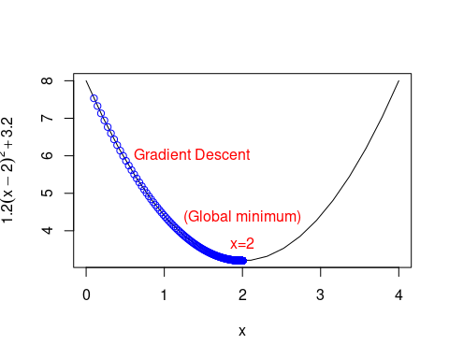

Conclusions
Gradient descent s an iterative first-order optimization algorithm used to find a local minimum/maximum of a given function. This works for differentiable and convex functions only. Learning rate (step size/alpha) is the size of the steps that are taken to reach the minimum. For our task, 0.01 was taken as the step size. The initial value was given as 0.1. The algorithm check all points till the minimum or maximum is reached. In this task it is minimum at x = 2. All the points in between are plot along with the function.

